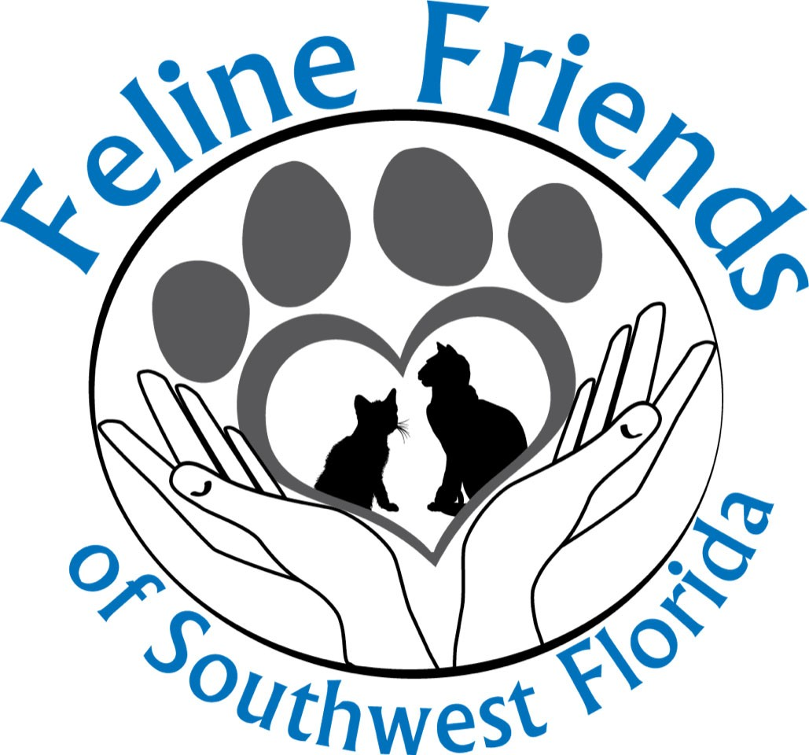

Feline Friends Foster Application and Agreement

Thank you for volunteering to be a Feline Friends Foster Parent. Our Fosters make a positive impact on the future of homeless cats and kittens in need.

Requirements
- Be at least 18 years of age.
- Complete a Feline Friends Volunteer application.
- Complete the Feline Friends Foster application and agreement.
- Allow a representative from Feline Friends to visit your home to assess where the foster cats and/or kittens will be living while in your care.

Contact Information

Name:

Street address:

City: State: Zip:

Home Phone _____________________ Cell Phone _______________________

Own:
Rent:
If you rent, are you allowed pets?

Landlord Name: Landlord Phone:

Do you have a separate room for your foster cats and/or kittens?

Do you have other pets? If so what type and how many:

Are all your pets current on vaccinations? _________

Have all your cat(s) been combo tested for FIV and FeLV? _______

Are all your pets spayed/neutered? ________

Do you have a vet? ________ If so, name, address, and phone number of your vet:

Your veterinarian’s name _____________________________

Address _____________________________________

Phone __________________

Relevant Experience
Please list all other foster or rescue programs in which you participate or have
participated, including feral cat care.

Please describe the area where the foster animal(s) will be kept:

How many hours will the cats(s) be alone each day?

Availability
What months can you foster? How many weeks at a time can you foster? 1-2 3-4 8 weeks
Over 8 weeks (whatever it takes)

Which cats are you interested in fostering?

Weaned healthy kittens Mom with kittens
Bottle kittens Adults
Describe why you want to be a foster parent:
Pregnant Cats Sick/injured cat Behavior cases Geriatric Cases

Terms of Agreement
- Approved foster parents agree to temporarily board and provide foster care for a mutually agreed upon duration.

- Foster parent agrees to follow the guidelines outlined by Feline Friends SWFL

- Feline Friends SWFL will make all decisions regarding the placement or removal of animals in foster care. Feline Friends SWFL will approve all foster decisions.

- Foster parent will provide in-home foster care at their listed address.

- The area designated for foster care will be segregated from all personal animals and from any other animals that foster parents may have in their household unless all animals are medically cleared and approved by Feline Friends.

- Foster parent will return animals at any time at the request of Feline Friends SWFL.

- Foster parent will provide daily:
  - Wholesome food and clean water, given at reasonable feeding times.
  - Accessible and clean litter box.
  - Bottle feeding (kittens) according to set intervals prescribed by Feline Friends SWFL.
  - Temperature controlled, safe and inviting environment.
  - Administration of medications and/or treatments if prescribed by a Feline Friends vet or vet tech.

  - Transportation of animals as required.
  - Socialization, play and love.
  - Recording of weight, health and social behavior as outlined by Feline Friends SWFL.
  - Reporting, in a factual manner, any dramatic change in health or behavior.

- Foster parent will provide bi-weekly a phone call or email to Dana and/or Cathy with a report of overall health and general well-being of animals in their care.

- Foster parents agree to contact Feline Friends SWFL to report emergencies involving fostered cats. Foster parents must seek approval for emergency veterinary care.

- Feline Friends SWFL will provide all pre-approved veterinary care and pay for all prescriptions as needed for foster cats. If emergency care is approved by Feline Friends SWFL foster parent will take the cat or kitten to the approved veterinarian.

- If foster parent chooses to take a foster cat to a private veterinarian without approval from
Feline Friends SWFL, reimbursements for medical expenses may not be paid.

- If foster parent chooses to provide supplies (food, litter, toys, etc.), they will be considered donations to Feline Friends SWFL. A donation receipt will be provided for tax purposes.

- Foster parents agree to return all loaned items and remaining supplies to Feline Friends SWFL in good/clean condition.

- Foster parent releases Feline Friends SWFL from and waives all claims and liability against Feline Friends SWFL for or attributable to any and all bodily injuries or property damage, losses, or injuries whatsoever to foster parent or other persons, or person’s animals and pets, caused by or arising out of the actions, behavior or health of the cats or arising out of the foster care.

- Foster parent certifies that their personal pets are currently up to date on all vaccinations, including rabies.

- Foster parent agrees to contact Feline Friends SWFL immediately in the event that foster parent can no longer care for any or all of the cats/kittens in their care.

- Foster parent may not entrust the care of the cats/kittens to any other person or relocate the animals. (Exceptions to this rule must be approved by Feline Friends SWFL)

- Foster parents understand that they do not have the right or authority to keep the foster cats or place the foster cats in other homes. In the event the foster parent or people they know wish to adopt their fostered cat, they must pass normal adoption screening regulations and agree to bring unaltered kittens to vet appointment arranged by Feline Friends SWFL for sterilization.

- Foster animals shall remain the property of Feline Friends SWFL unless and until foster parents adopt the animals as provided in paragraph 18 above.

- Foster parent will advise Feline Friends of any change in address telephone numbers before they become effective.

- Agents of Feline Friends will be permitted to inspect the foster parent’s house at any time in which the cats/kittens are in their care.

- Foster parent agrees to immediately report the death of any foster cat or kitten to a Feline Friends vet tech, Cathy (973) 216-8018 or Dana (941) 894-0929.

- Foster parent is aware of the potential that certain zoonotic diseases can be passed along to humans (e.g., scabies, ringworm, giardia, etc.) and foster parent releases Feline Friends SWFL from and waives all claims and liability against Feline Friends SWFL for, any and all medical expenses related to or arising out of treatment of foster parent or any member of foster parent household or persons who may contract such disease.

- This Agreement is the entire agreement between foster parent and Feline Friends SWFL. Any modification to the Agreement must be in writing and signed by both foster parent and Feline Friends.

Foster Parent

Signature: ____________________________________________ Date: ________

Feline Friends SWFL

Signature: _______________________________________________ Date: _________

